SP2025 Public Consultation

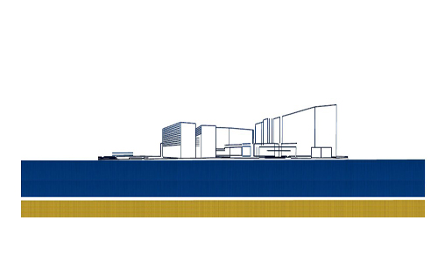

The Office has just completed its public consultation for the Strategic Plan 2025 (SP2025) and the contributions were both insightful and comprehensive. This public consultation on the draft SP2025 – from June 25 to September 17 - followed a first [consultation](https://euipo.europa.eu/ohimportal/strategic-plan#SP2025) on the three strategic drivers, which was held at the beginning of the year.

As with the first consultation, this public consultation allowed interested parties to have their opinions heard and for the Office to further refine the SP2025 draft. The information is being reviewed and all contributions are being considered as to how they can play a part in the SP2025.

The Office would like to thank the National Intellectual Property Offices, User Associations, and all other stakeholders for their valuable contributions. The collaborations between the EUIPO and stakeholders helps to shape the future of the Office in a way that reflects upon the positive work carried out by all.

The contributions received with consent for publishing, can be accessed via [this link](https://euipo.europa.eu/ohimportal/strategic-plan#SP2025).